We have used two data sets –

1.KDD1999

2.NSL-KDD

**The main aim of the below experiments is to find which method will be best to train the ML model by converting time domain data into frequency domain.**

**Before applying fourier transform**-

|  |  |  |
| --- | --- | --- |
| **Model** | **Data sets** | **Accuracy** |
| KNN | KDD1999 | 0.9979859 |
| R. Forest | KDD1999 | 0.9997065 |
| D Tree | KDD1999 | 0.9994130 |
| LSTM | KDD1999 | 0.99 |
| KNN | NSL-KDD | 0.9786069 |
| R. Forest | NSL-KDD | 0.9984918 |
| D Tree | NSL-KDD | 0.9966660 |
| LSTM | NSL-KDD | 0.99 |

**After applying Fast Fourier Transforms** –

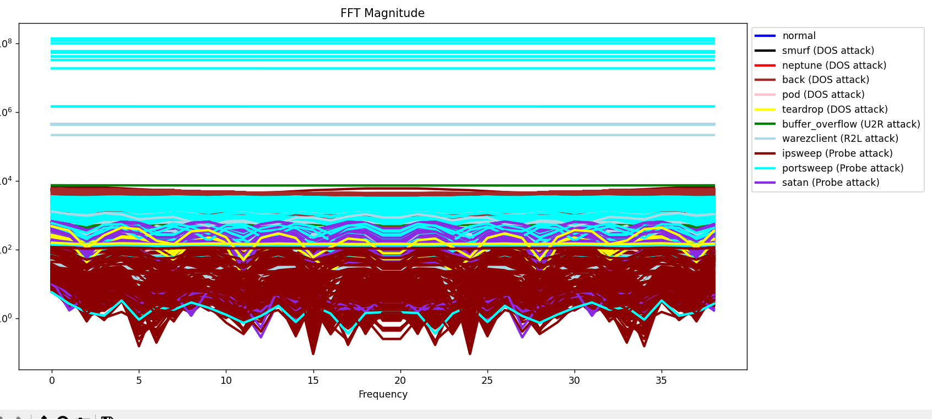

|  |  |  |  |
| --- | --- | --- | --- |
| **Model** | **Data sets** | **Accuracy** | **Change** |
| KNN | KDD1999 | 0.9975710 | **Decrease** |
| R. Forest | KDD1999 | 0.9977835 | **Decrease** |
| D Tree | KDD1999 | 0.9989997 | **Decrease** |
| LSTM | KDD1999 | 0.9890593 | **Decrease** |
| KNN | NSL-KDD | 0.9744791 | **Decrease** |
| R forest | NSL-KDD | 0.9800357 | **Decrease** |
| D Tree | NSL-KDD | 0.9690415 | **Decrease** |
| LSTM | NSL-KDD | 0.9332010 | **Decrease** |

**\*\* We do not use KDD99 from now as it has a lot of garbage data because of which we get very high accuracy (sometimes of 1) which is unexpected**

**After applying Z Transform**

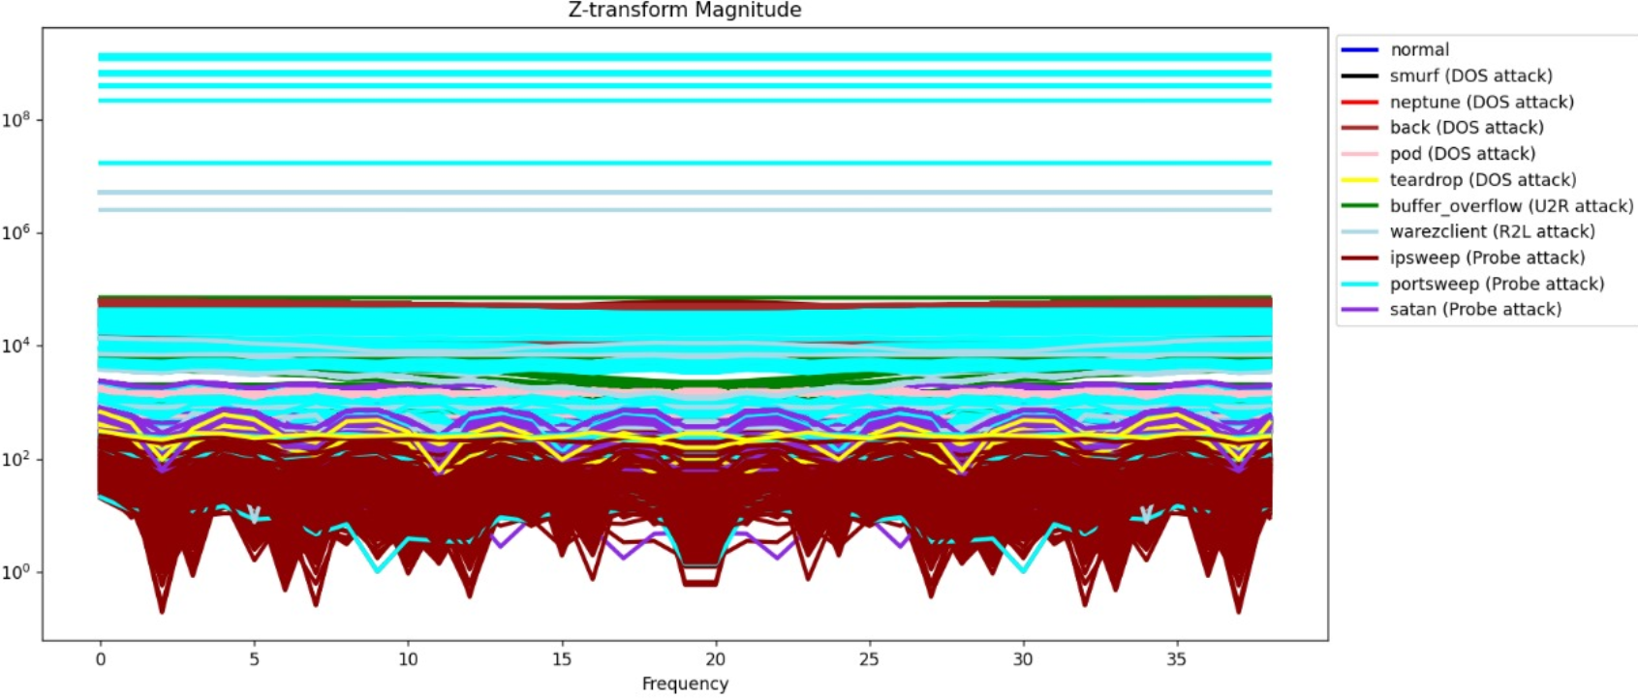

|  |  |  |  |
| --- | --- | --- | --- |
| **Model** | **Data sets** | **Accuracy** | **Change** |
| KNN | NSL-KDD | 0.983 | **Increase** |
| R forest | NSL-KDD | 0.985 | **Decrease** |
| D Tree | NSL-KDD | 0.977 | **Decrease** |
| LSTM | NSL-KDD | 0.946 | **Decrease** |

**After applying STFT (Short Time Fourier Transform)**

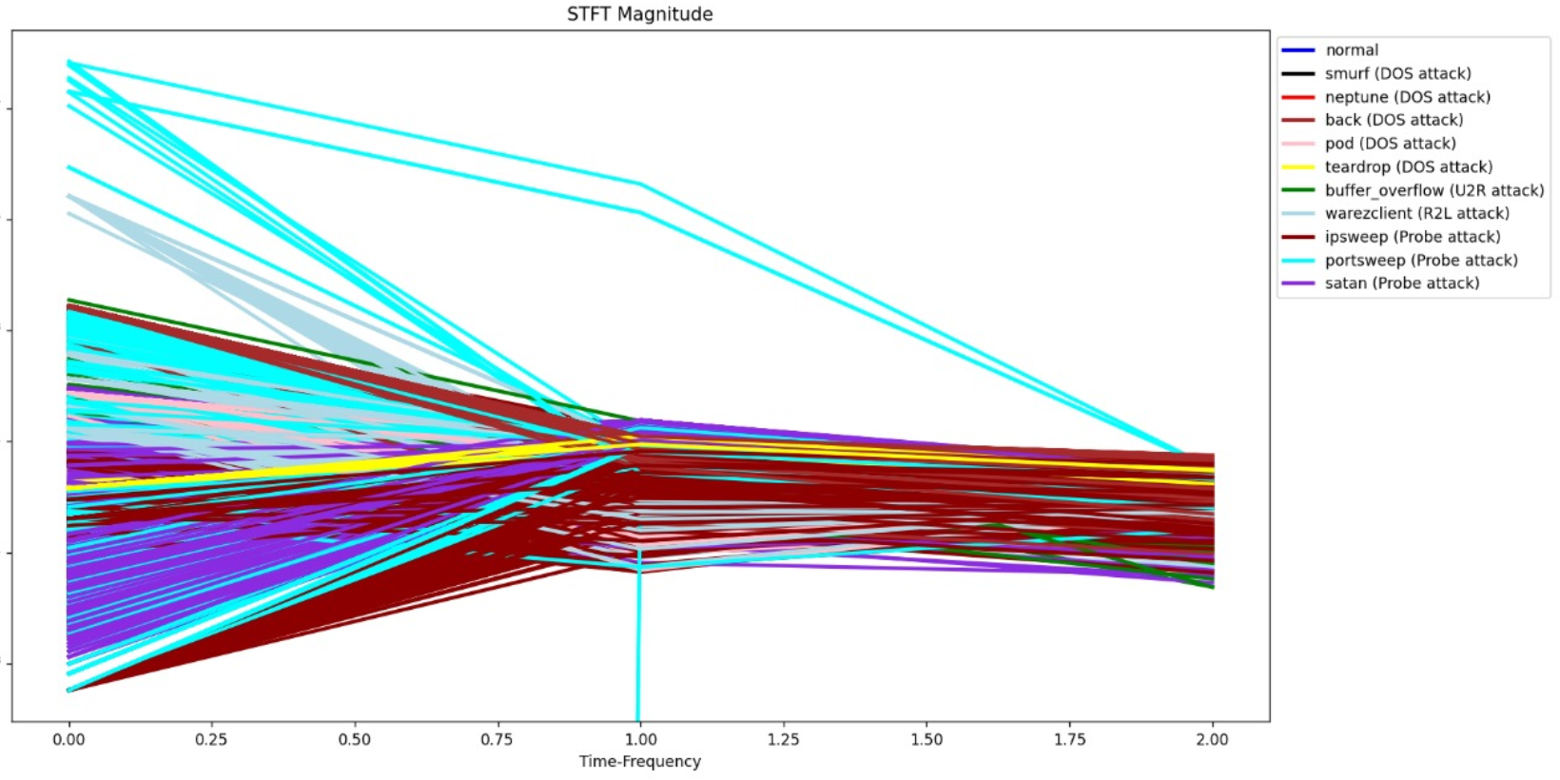

|  |  |  |  |
| --- | --- | --- | --- |
| **Model** | **Data sets** | **Accuracy** | **Change** |
| KNN | NSL-KDD | 0.985 | **Increase** |
| R forest | NSL-KDD | 0.9932 | **Decrease** |
| D Tree | NSL-KDD | 0.9898 | **Decrease** |
| LSTM | NSL-KDD | 0.947 | **Decrease** |

**\*\*\*After applying Wavelet Transform**

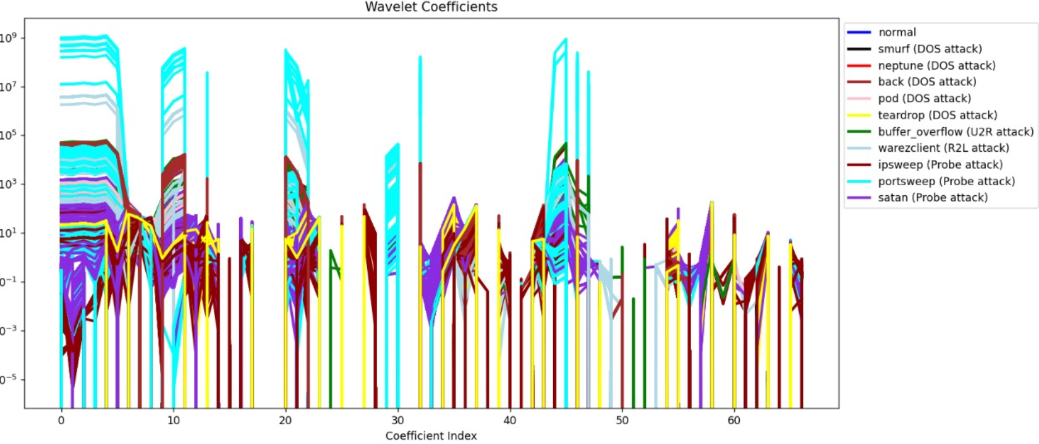

|  |  |  |  |
| --- | --- | --- | --- |
| **Model** | **Data sets** | **Accuracy** | **Change** |
| KNN | NSL-KDD | 0.985 | **Increase** |
| R forest | NSL-KDD | 0.9984 | **Increase** |
| D Tree | NSL-KDD | 0.9970 | **Increase** |
| LSTM | NSL-KDD | 0.994 | **Increase** |

**After applying Hilbert Transform**

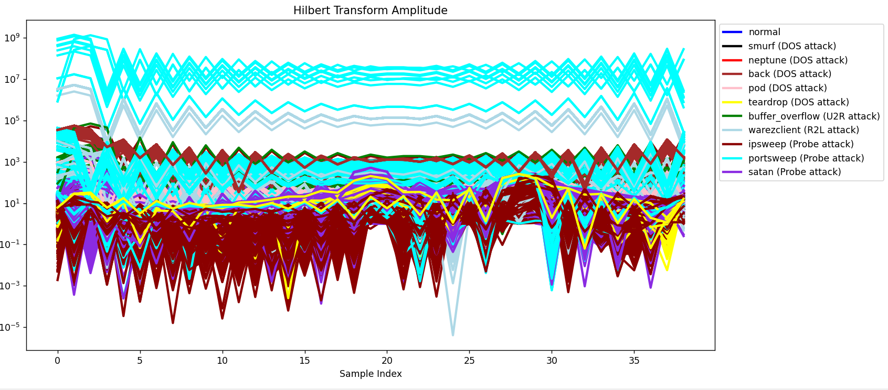

|  |  |  |  |
| --- | --- | --- | --- |
| **Model** | **Data sets** | **Accuracy** | **Change** |
| KNN | NSL-KDD | 0.983 | **Increase** |
| R forest | NSL-KDD | 0.994 | **Decrease** |
| D Tree | NSL-KDD | 0.9906 | **Decrease** |
| LSTM | NSL-KDD | 0.68 | **Decrease** |

Conclusion:

Wavelet Transform is best for converting time domain network data into frequency domain for training the ML model for classifying different types of attacks.